**Home Page**

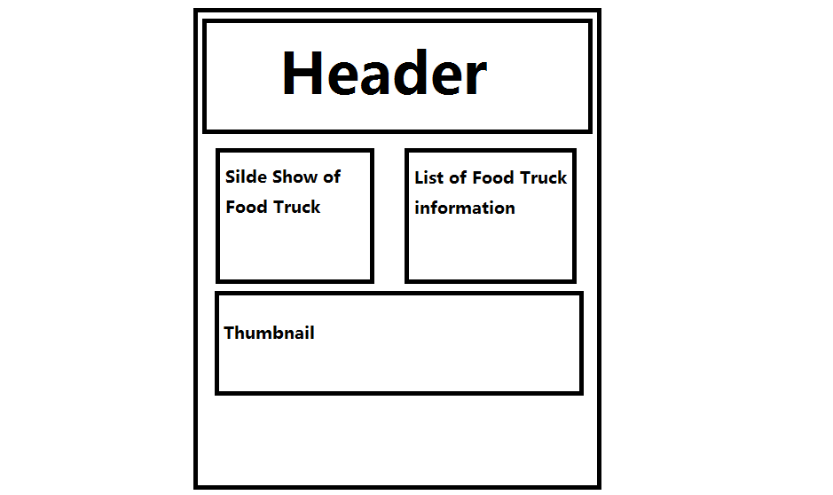

**Sign Up Page**

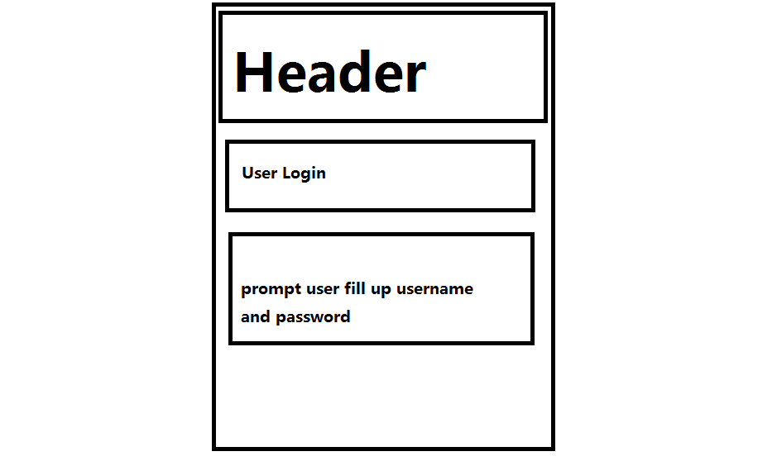

All the Sign in/Up pages are same layout.

**Food Truck Page**

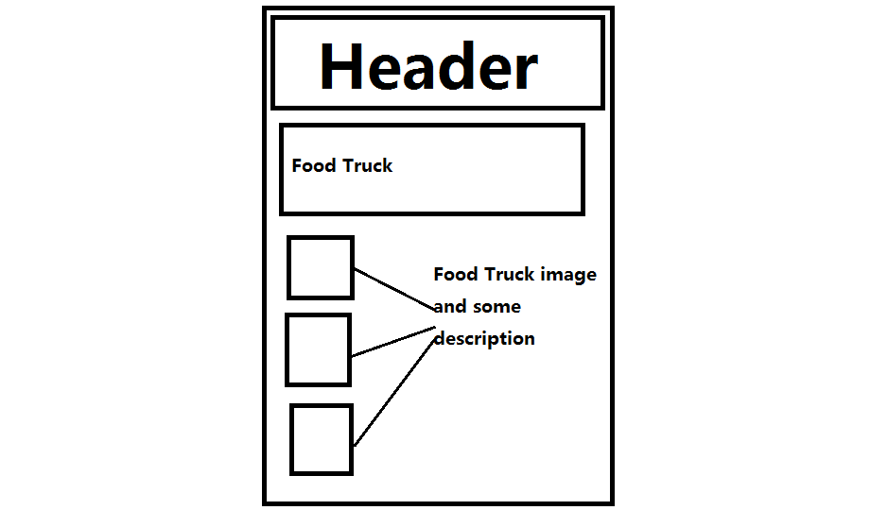

Food Menu will have the same layout with Food Truck Page.

**SiteMap**



**Test Result**

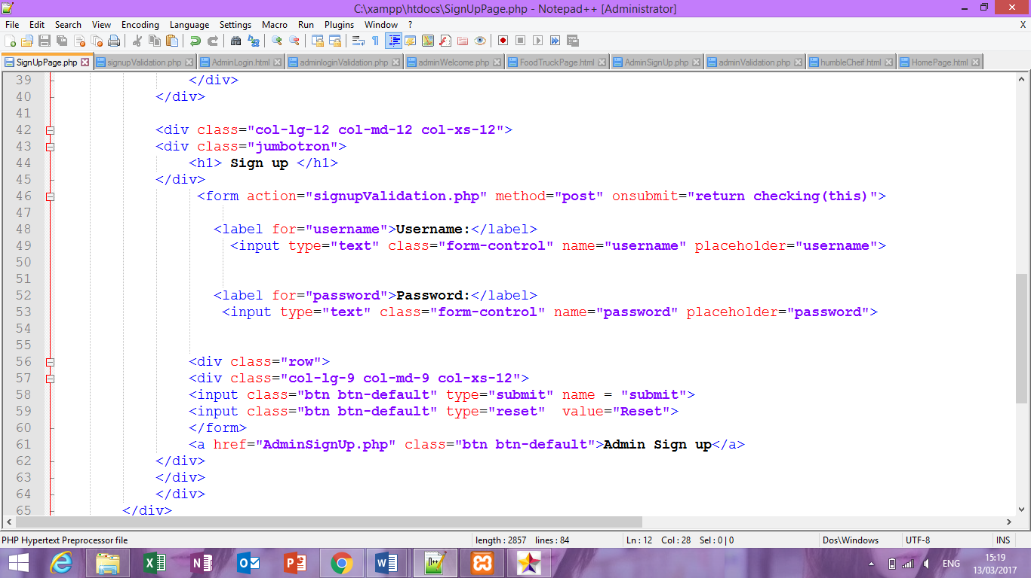

Before I correct the code of SignUpPage, I have the problem which is cannot save data to database after I click the submit button.   
so how I solve this problem, I change the submit from “Submit” to “submit” and put “</form>” tag cover the button and solved the problem.

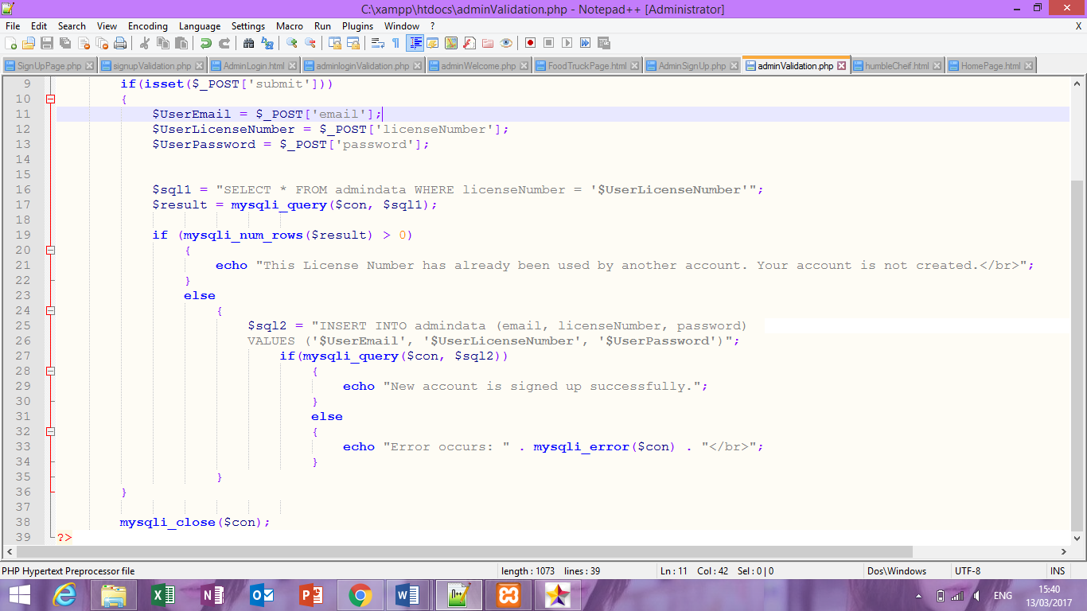

This is AdminSignUp page. There are same problem that I encountered with SignUpPage, for the $spl 2= INSERT…email, licenseNumber, password….’$UserPassword’ , this is the code that corrected before corrected the code was $UserEmail,$UserLicenseNumber,$UserPassword. This “$UserEmail…. $UserPassword” should be type in the name that I type in code not the variable, this is the reason why data are not save into database.